



Did you know there are 3 recommended vaccines for preteens? HPV, Tdap, and Meningitis. These preteen vaccines help the body fight off serious diseases and keep children safe as they grow up.

HPV vaccine protects girls and boys from the human papilloma virus (HPV), which causes 6 types of cancer. HPV vaccine works best when given at ages 11 or 12. The HPV vaccine is given as 2 shots, 6 – 12 months apart (or 3 shots if started after age 15).

Tdap vaccine protects against 3 serious diseases: tetanus (lockjaw), diphtheria, and pertussis (whooping cough). Preteens should get this vaccine at ages 11 – 12.

Meningitis vaccine protects against bacteria that can cause meningitis (swelling of the lining around the brain and spinal cord) and sepsis (infection in the blood). Preteens should get this vaccine at ages 11 – 12, followed by a booster at age 16.

We will offer these recommended vaccines at your child’s next visit

For more information about these vaccines and how you can protect your child, visit get3shots.org

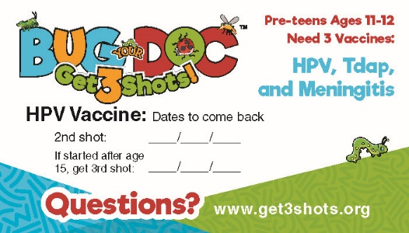

**You can use this email in place of the Bug Your Doc Mailer.
Send to your 11-12 year old patients prior to their visit

